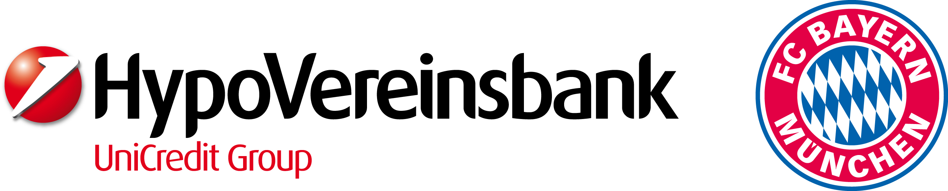

invite and welcome you to our …

buntkicktgut-open 2010
UniCredit-Cup
in the categories “boys or mixed” U13/U15/U17 and “ladies” U19
May 20th-24th, 2010
Olympiapark Munich

Short information about planned items

- Four day program with workshops, performances and a public discussion around the main event: the streetsoccer-tournament buntkicktgut-open
- all in all 32-40 streetsoccer teams in four categories
(“boys or mixed” U13/U15/U17 and “ladies” U19), one half of them from Munich and the second half from other cities, countries and continents
- playground is an artificial turf on two streetsoccer courts
- three-day tournament (every team will play on two of the three days)
- Thursday 20th: Arrivals, reception and opening, public discussion
Friday-Saturday 21st-22nd: qualification / group stage for all teams, workshops
Sunday 23rd: playoff, final and solace rounds for all teams
Monday 24th: conclusion and departure
- workshops on different subjects for all participants on their off-play-time
- opening discussion with experts from different professional fields and disciplines
- Saturday evening: we will look for a common evening including TV-viewing of the European Champions League Final (Madrid).

We will send you further information after receiving your application.

Still first questions?
Please contact: team@buntkicktgut.de (+49-89-510861-11)
Matthias Groeneveld (m.groeneveld@buntkicktgut.de)
Sokol Lamaj (s.lamaj@buntkicktgut.de)
Niels Nürnberger (n.nuernberger@buntkicktgut.de)
Lucia Hartmann (l.hartmann@buntkicktgut.de)
Rüdiger Heid (r.heid@buntkicktgut.de / +49-89-510861-16 / mobile: +49-89-173-3695918)

postal address:
Rüdiger Heid
director
buntkicktgut – international streetfoolball league munich
ig-feuerwache, ganghoferstraße 41, D-80339 München

www.buntkicktgut.de
www.munich06.org

